HR EMPLOYEE ATTRITOIN ANALYSIS

## PROJECT OVERVIEW
Employee attrition is a critical challenge for organisation as it increases recruitment costs, affects productivity and impacts overall business performance. This project analyzes HR data to identify workforce trends, understand the factors contributing to employee attrition.
An interactive dashboard was developed in **Microsoft Excel** using Pivot Tables, Charts, KPI Cards and Slicers to monitor key workforce metrics and support data-driven decision making.
---

## BUSINESS PROBLEM
### The HR department wants to answer the following business questions:
- Which department experience the highest employee attrition?
- Which job roles have the highest turnover?
- Does overtime contribute to employee attrition?
- Which employee age groups have highest attrition and require better retention strategies?
- How does salary vary across departments?
---

## DATASET OVERVIEW
### The dataset contains employee demographic information, department details, salary, overtime status, work experience, job satisfaction, and attrition records.
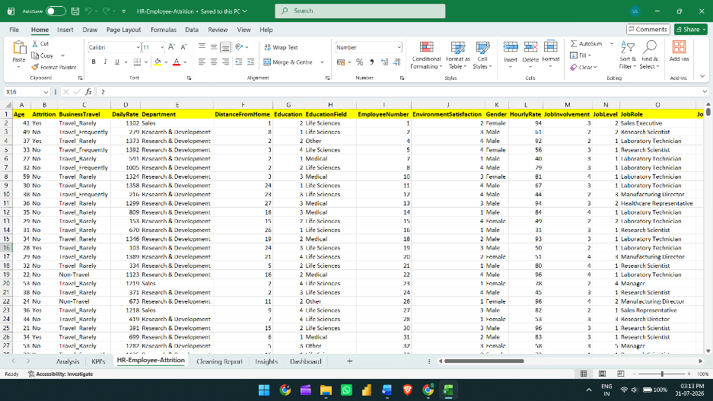

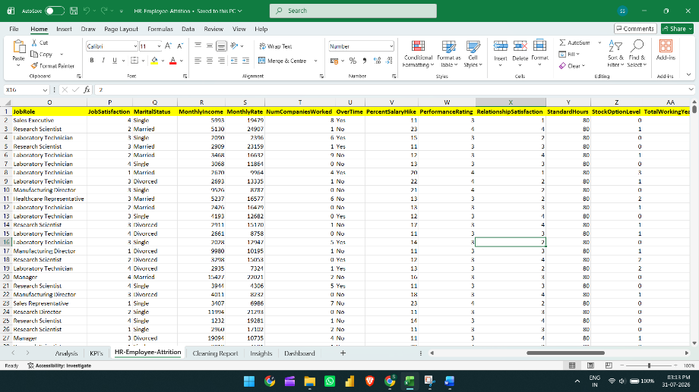

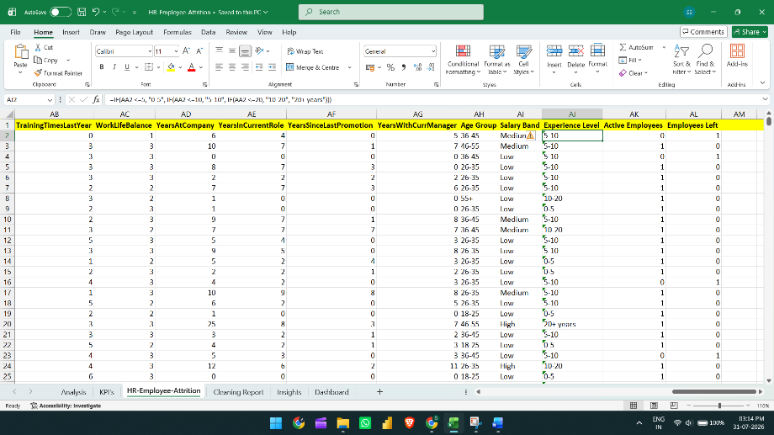

## TOOLS AND EXEL FEATURES USED
- Excel Tables
- Pivot Tables and Carts
- KPI Cards
- Conditional Formatting
- COUNTIF & IF Functions (Age group, Salary band, Experience level, Active employees)
- Data Validation
---
## DATA CLEANING AND TRANSFORMATION
- Converted the dataset into Excel Table for dynamic analysis.
- Checked for missing values and duplicate Employee Numbers.
- Validated data consistency across categorical columns.
- Removed unnecessary columns with constant values like Above 18 ages.

- Created helper columns for:
- Age Group
- Salary band
- Experience level
- Active employees
- Employees left

---

## DASHBOARD FOR ANALYSIS
### KPI Cards
- Total employees
- Active employees
- Employees left
- Attrition rate
- Average salary
- Average experience

### Interactive Visualizations
- Attrition by department
- Gender distribution by attrition
- Overtime vs attrition
- Attrition by job role
- Attrition by age group
- Average monthly salary by department

### Interactive Filters
- Gender
- Job role
- Overtime
---

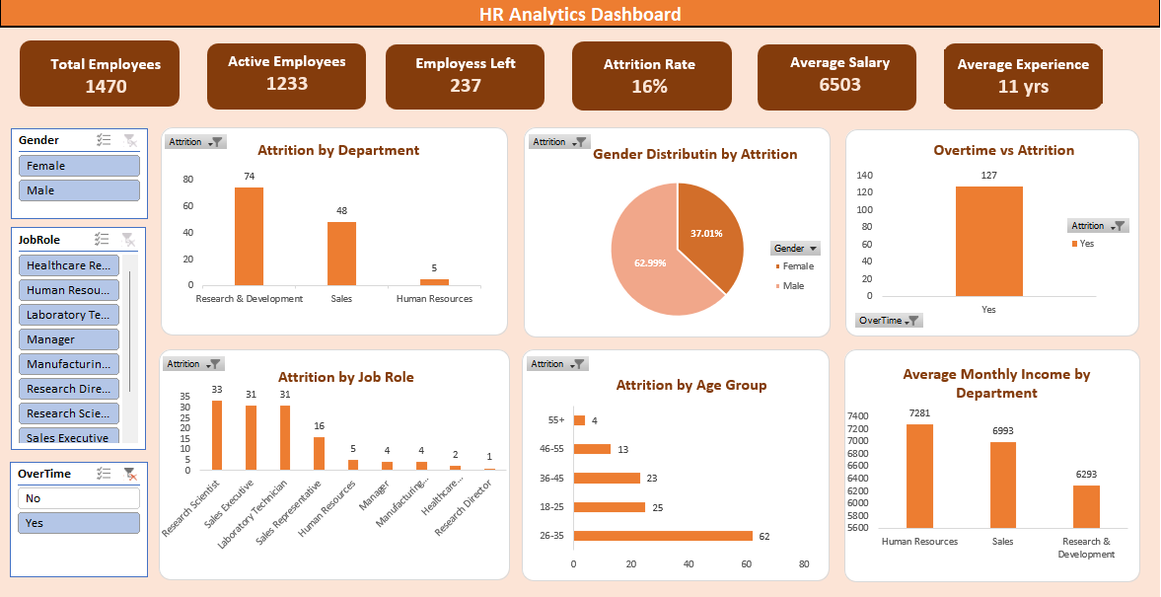
## DASHBOARD PREVIEW

## KEY INSIGHTS
- 1The organisation has 1470 total employees of which 237 left, resulting in an attrition rate of 16%.
- The Research and Development department recorded the highest employee attrition (133 employees) , followed by Sales (92 employees) while Human Resources had the lowest attrition (12 employees).
- Laboratory Technician (62 employees) and Sales Execution (57 employees) experienced the highest employee turnover among all job roles.
- The (26-35) age group recorded the highest employee attrition, suggesting that early to mid-career employees are more likely to leave the organisation.
- The Average Monthly Income across the organisation is 6503 with the Human Resource department reporting the highest average salary among the departments.
---

## BUSINESS RECOMMENDATIONS
- Prioritize retention initiatives like career growth, rewards, compensation and workplace flexibility in the Research and Development and Sales departments, which together account for 225 of the 237 attrition cases
- Review overtime policies and workload distribution, especially for employees regularly working overtime, to help reduce burnout and salary enhancement to improve retention.
- Take feedback suggestion discussions and career development with employees in those roles which they have the highest turnover to know the employee’s needs.
- Develop targeted engagement and career growth programs for the employees in the 26-35 age group where attrition is highest.
- Monitor promotion cycles and identify employees with long promotion gaps to improve career growth and employee satisfaction.
---

## CONCLUSION
### The project demonstrates the understanding of employees, their attrition records and how they can improve by using actionable insights.

## Author: Sneha Sharma
www.linkedin.com/in/12sneha-sharma

